**FILTER #01**

**ip.addr==10.20.6.77**

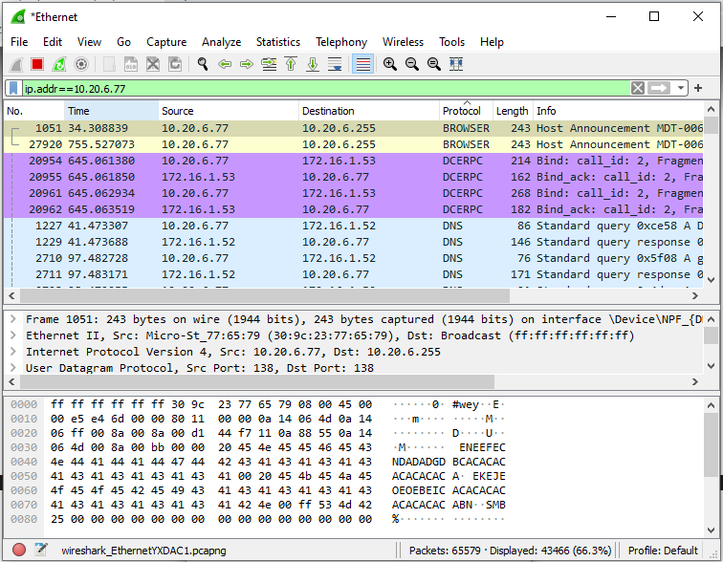

**FILTER #02**

**ip.src==10.20.6.77**

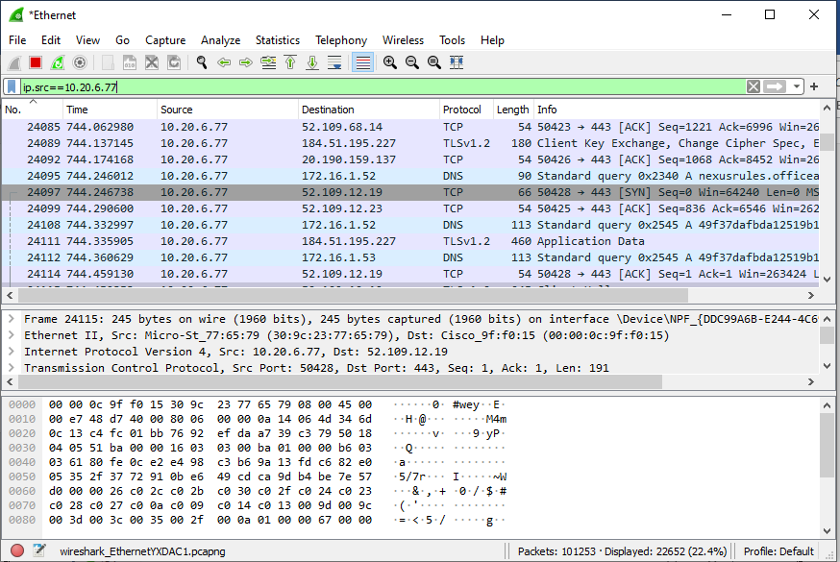

**FILTER #03**

**ip.dst==10.20.6.77**

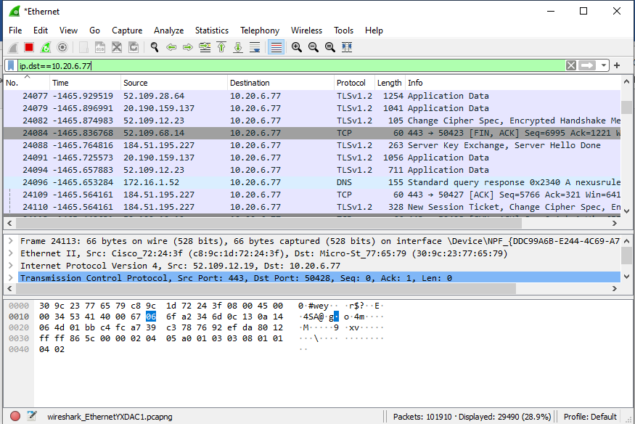

**FILTER #04**

**ip.addr==10.20.6.77/24**

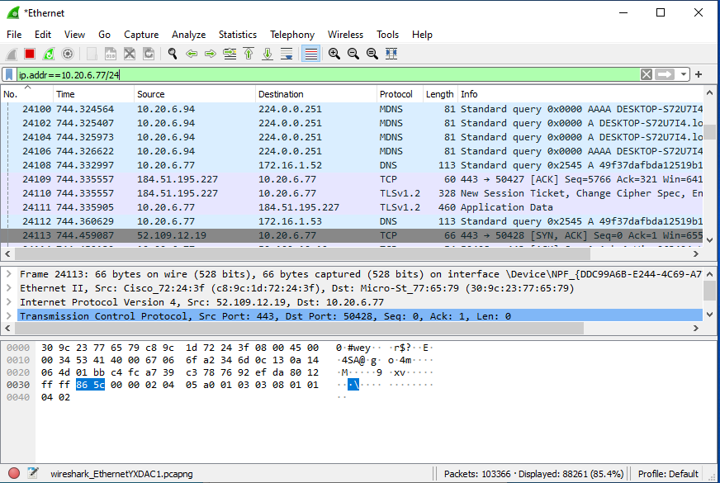

**FILTER #05**

**Dns**

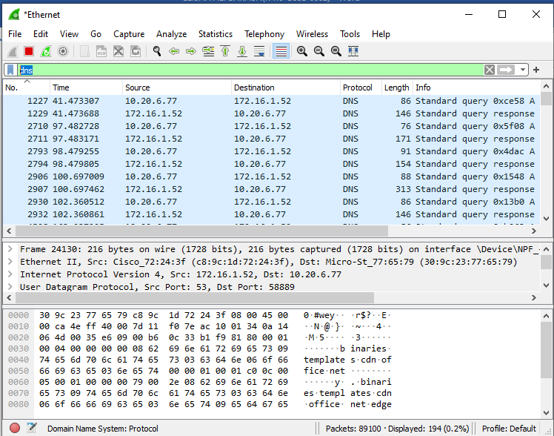

**FILTER #06**

**!ip.addr==10.20.6.77**

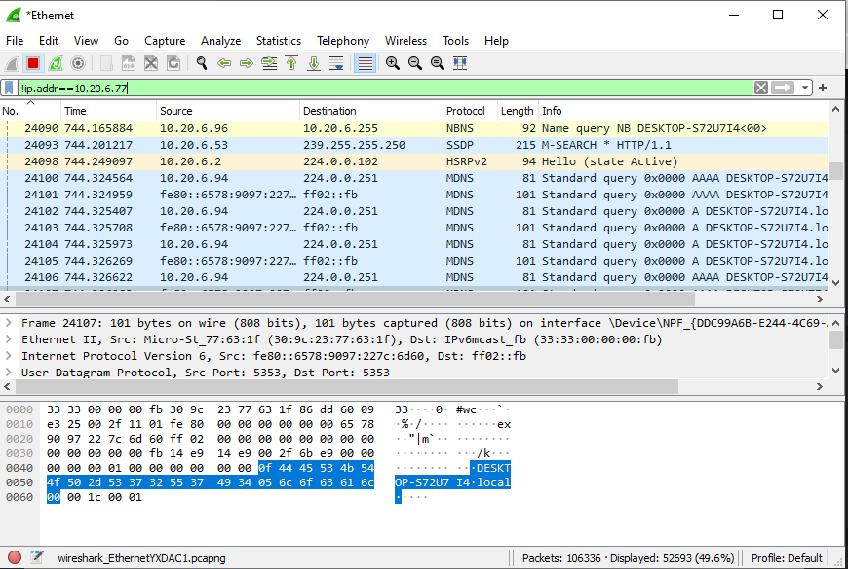

**FILTER #07**

**ip.addr==10.20.6.77/24 and ip.addr==10.20.6.254/24**

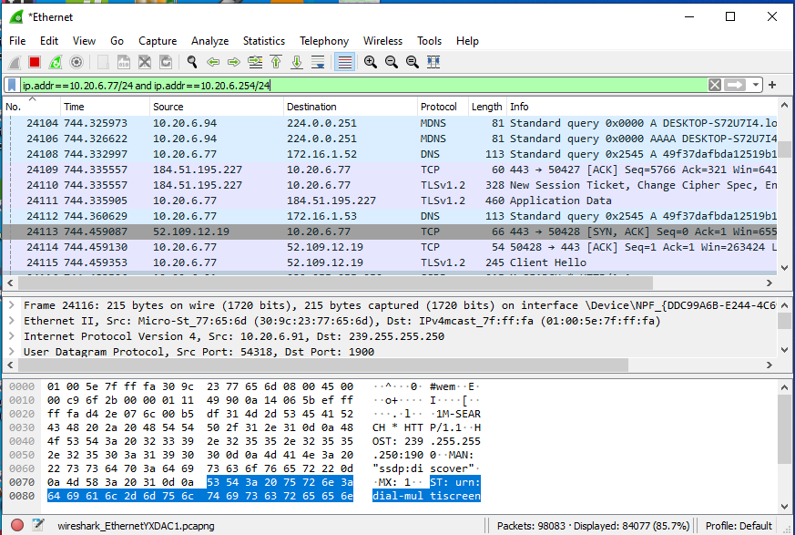

**7b**

**ip.addr==10.20.6.77 and ip.addr==10.20.6.254**

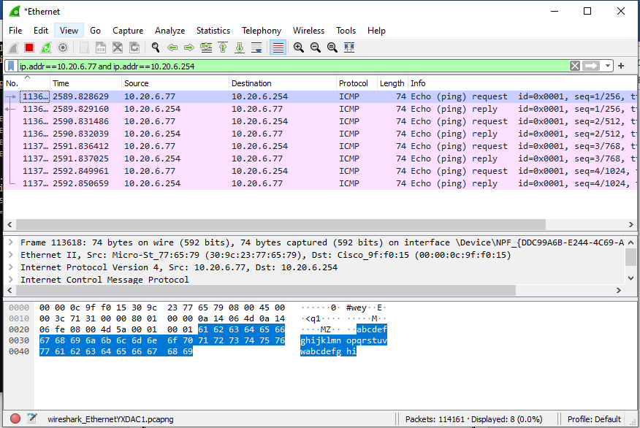

**FILTER #08**

**eth.addr == 30:9C:23:77:65:79**

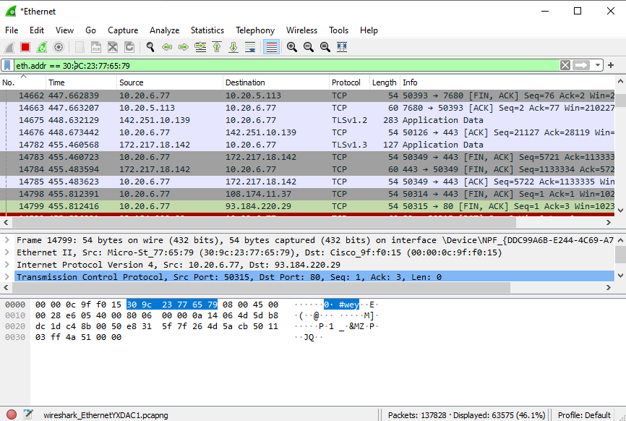

**FILTER #09**

**tcp.port==80**

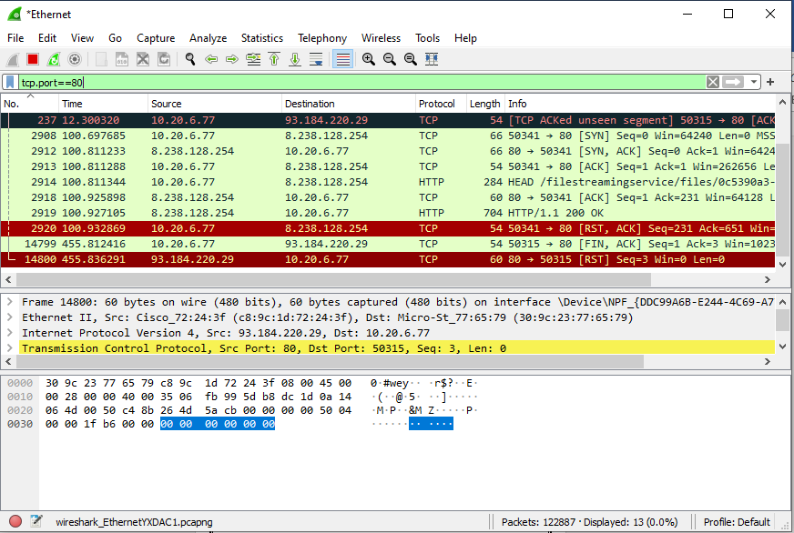

**tcp.srcport==80**

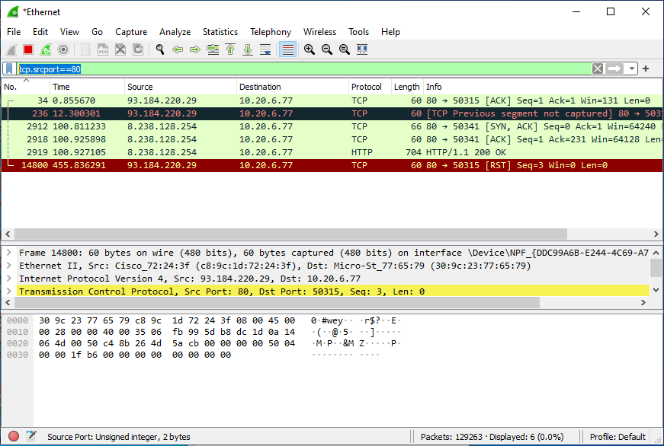

**tcp.dstport==80**

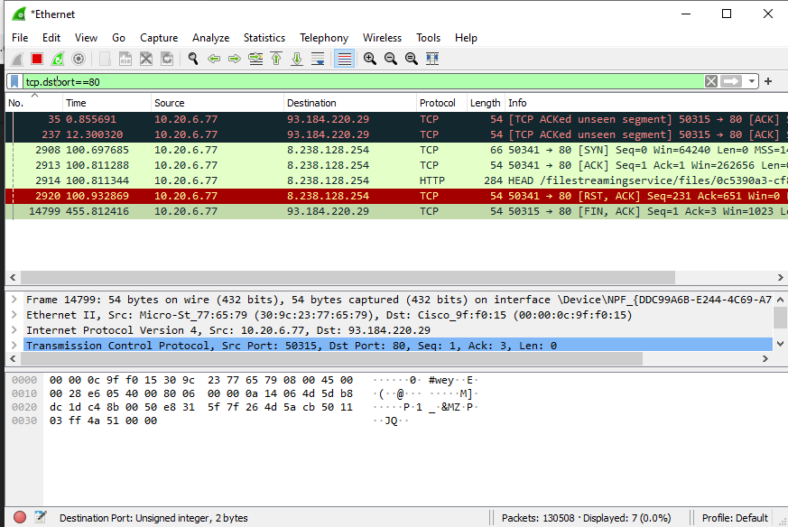

**FILTER #10**

**http.user_agent contains Firefox**

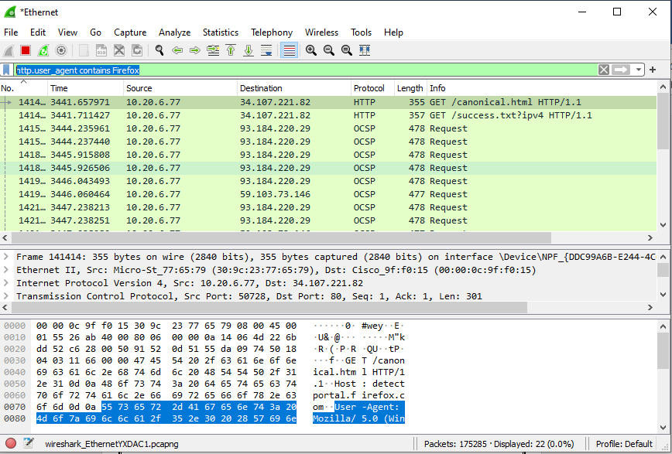

**!http.user_agent contains Firefox || !http.user_agent contains Chrome**

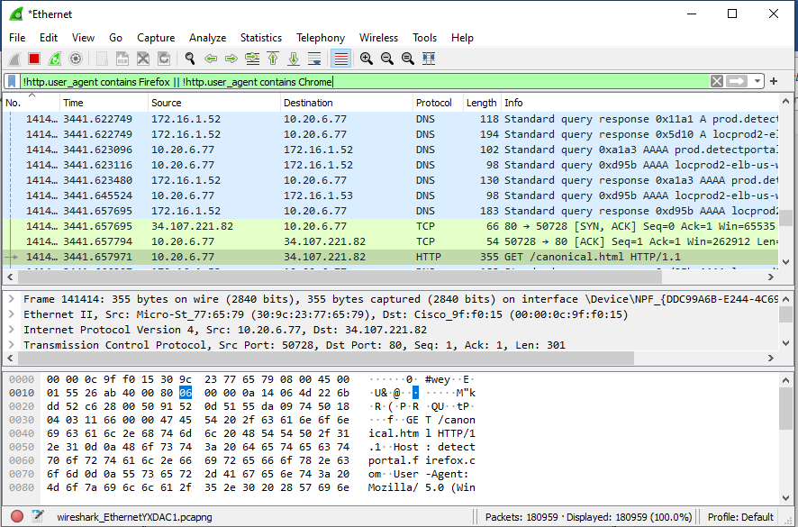

**FILTER #11**

**tcp.port==80 && ip.addr==10.20.6.77**

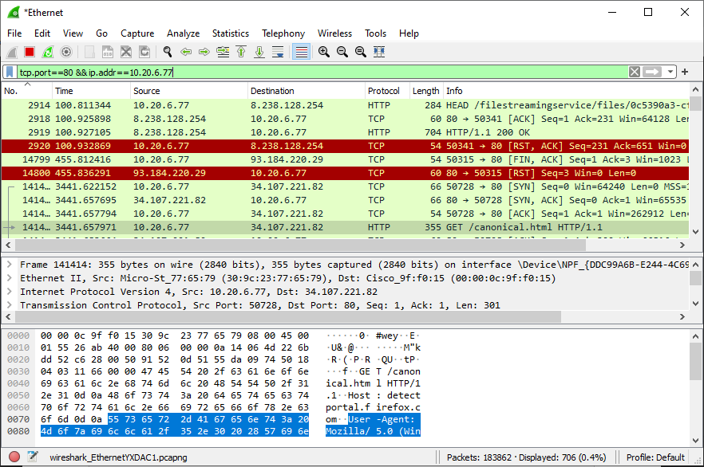

**FILTER #12**

**Http.request**

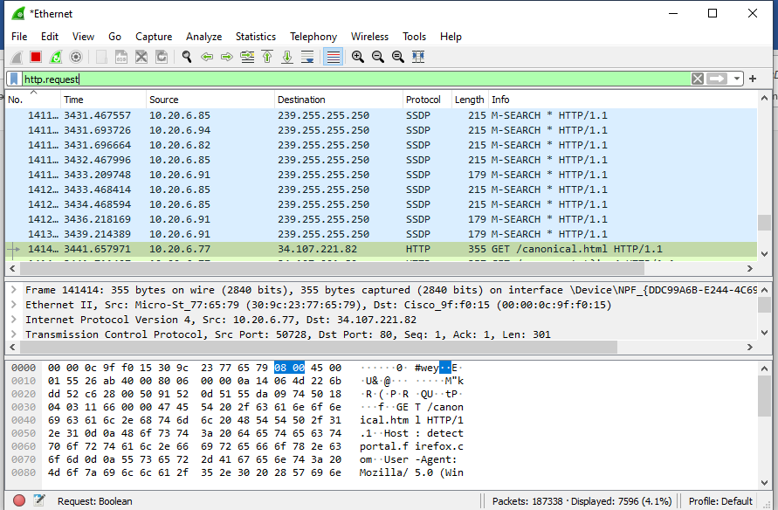

**FILTER #13**

**http.request or http.response**

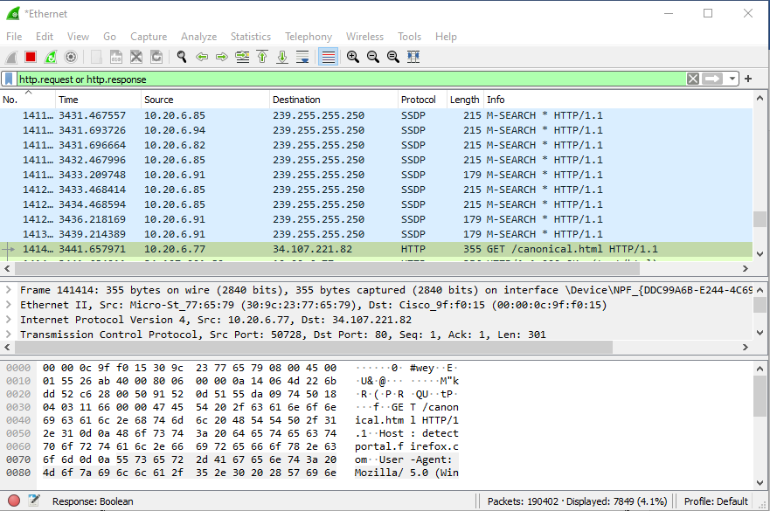

**FILTER #14**

**frame contains "(attachment|tar|exe|zip|pdf)"**

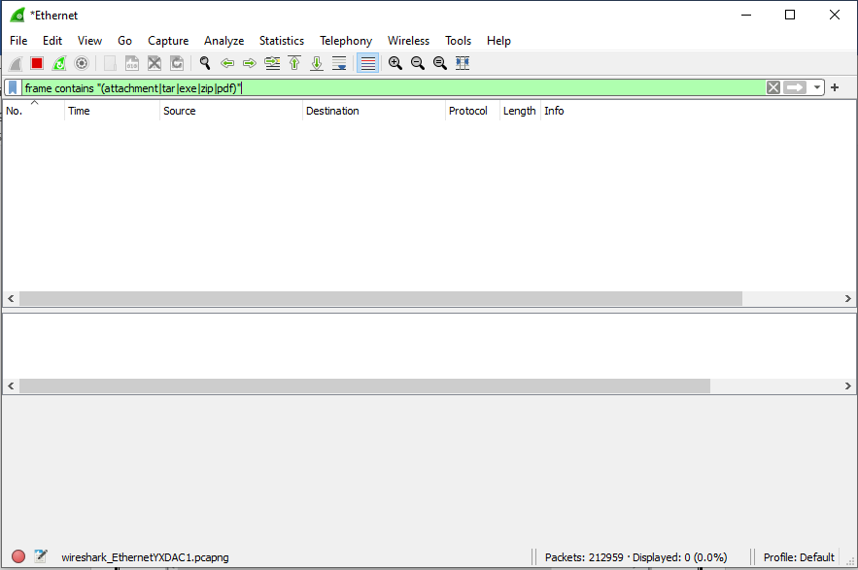

**FILTER #15**

**tcp contains facebook**

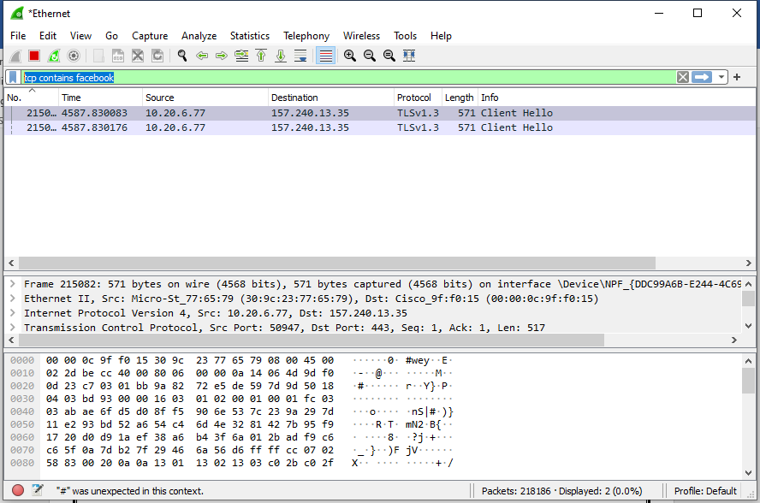

**frame contains facebook**

